Creating a Voice Thread

Go to Voice Thread at http://voicethread.com
Click on Sign in or Register in the top right corner.
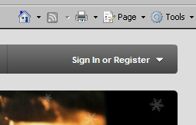

Enter your username and password.

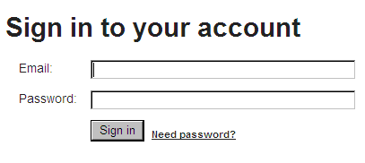

Now you are ready to get started!! Click Browse, Create, or My Voice from the menu below.
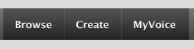

Browse lets you view projects that other people have done.
Create lets you begin creating your own Voicethread project.
My Voice lets you see all of the Voicethread projects you’ve made.

The instructions below are a simple guide to get started.
Once you’ve registered, your account can be found under the My Voice tab.

To create a Voice Thread, click on Create.

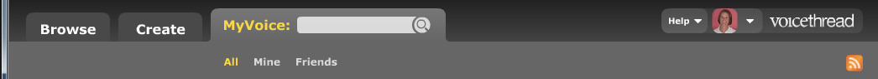
The Voice Thread can be created from this screen.

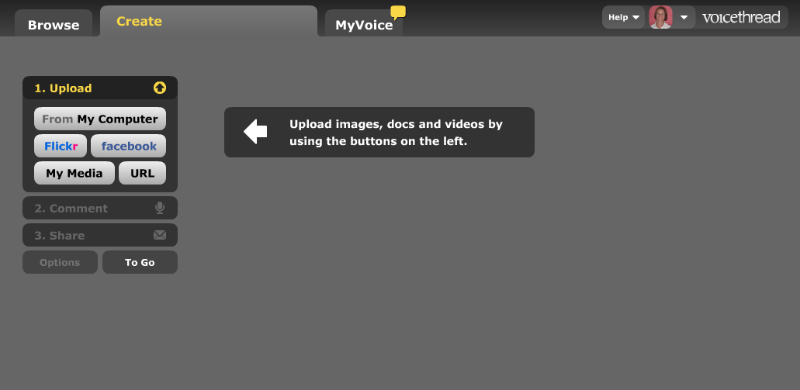

Upload pictures by clicking the Upload button.

Once images are loaded, you can click on Edit title to add the name of the Voice Thread and description.

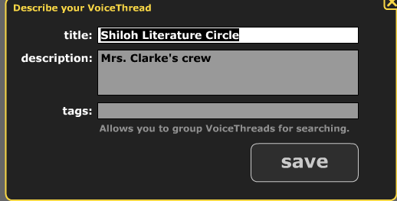
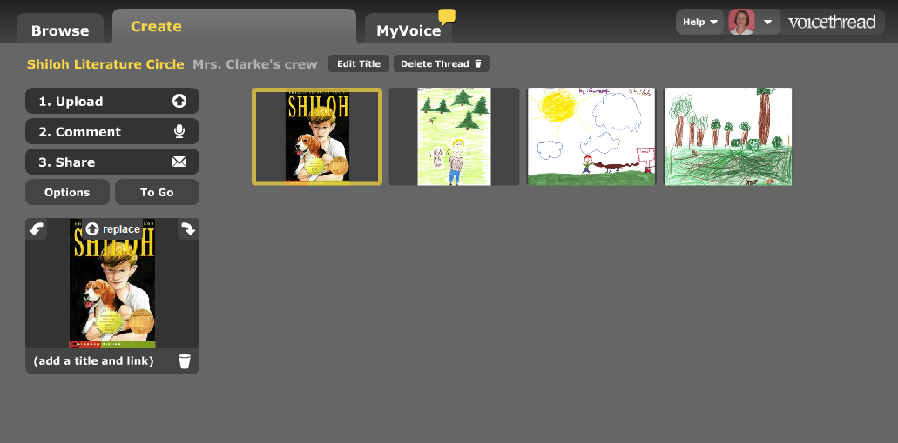

To add voice comments, click on Comment.
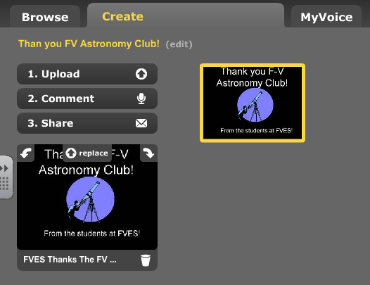

Then click on the picture that is displayed at the bottom.


A list of identities will appear. Choose one to represent yourself. We use these identities to represent students instead of their photograph for security purposes.
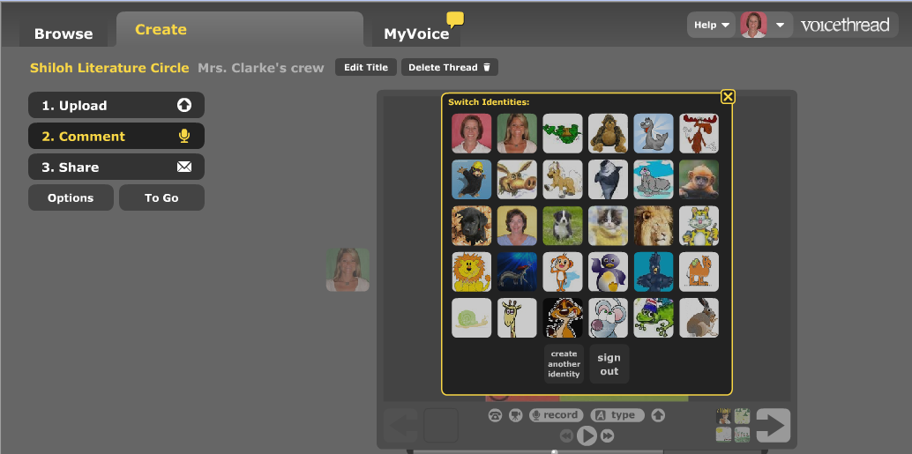

Make sure a microphone is plugged into your computer, then press Record.

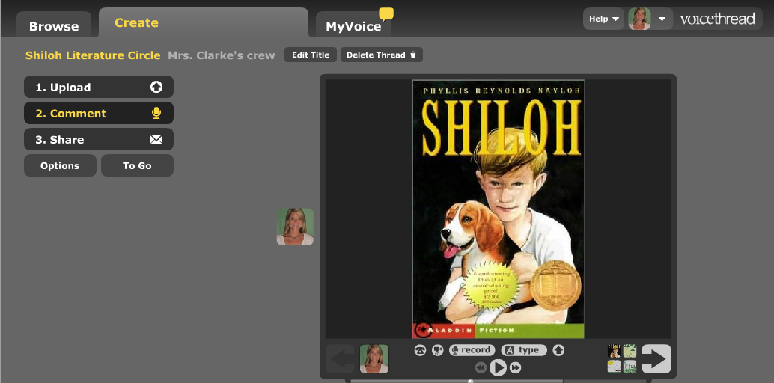

A box will appear requesting access to your computer to record, click yes.

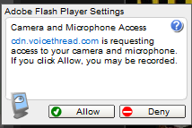

The screen will look like this when recording. Click the Stop Recording button when finished.

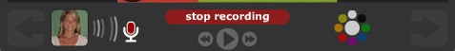

The sound clip will automatically replay. You can choose save or cancel.

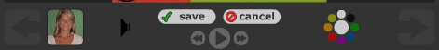

If you record more than one sound clip, it will be added to the end of the sound clip before it.

Click one of the colors to write on the picture while you are talking. This is such a cool feature.

To type a message instead of record, click Type and type your message in the box that appears.

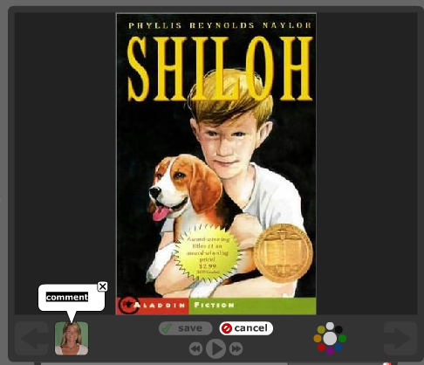

Repeat the Upload process to add more pictures to your VoiceThread.
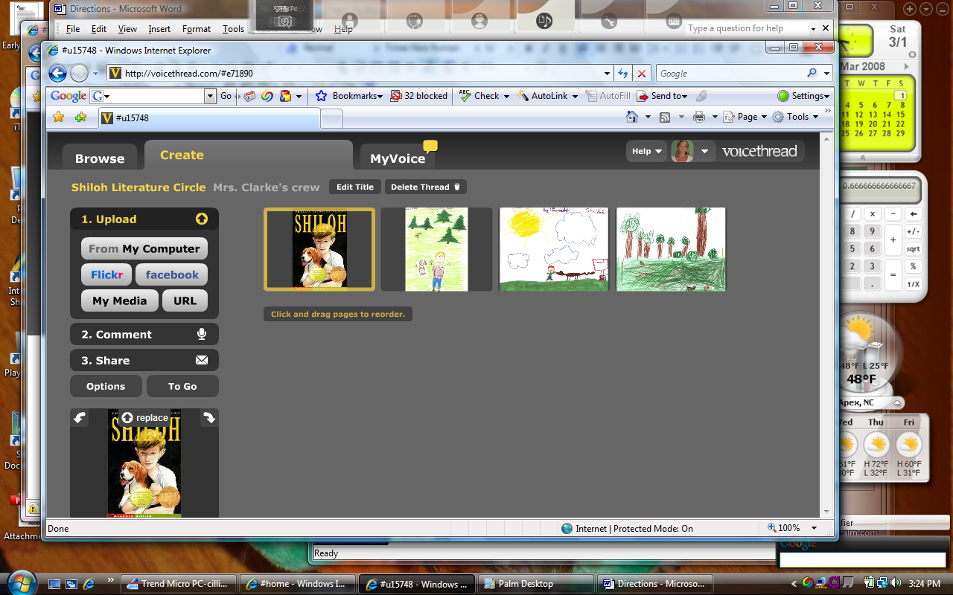

Click on Share to determine if the Voice Thread is private or public.
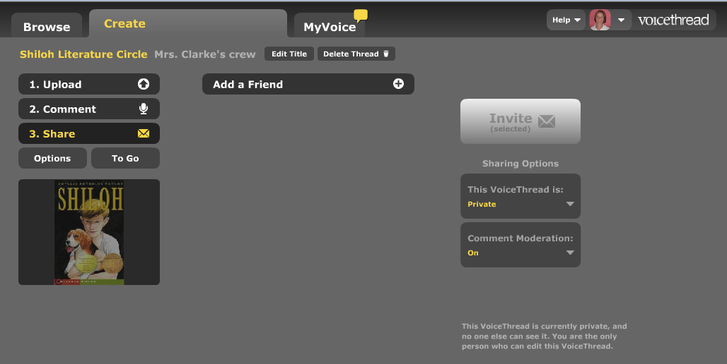

Edit the slide progression by clicking Options.

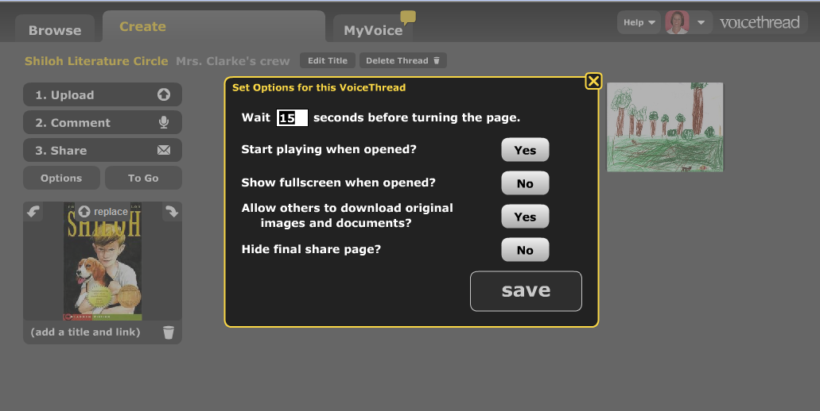

To get the kids started, you can distribute an instruction sheet for logging onto Voice Thread. It should include the web address, school user name (email account) and password (same one for everyone).

